**CST325 HW 3.2 – Matrix Details**

**(xx question points weighted to 75 grade points)**

1. (True / False) Determine the validity of each equation for the matrices A and B. (5 pts)
   1. $A^{-1}B=BA^{-1}$ TRUE
   2. $AB=BA$ FALSE
   3. $A^{-1}BA=ABA^{-1}$ TRUE
   4. ${\left(AB\right)}^{T}=A^{T}B^{T}$ FALSE
   5. ${\left(AB\right)}^{-1}=B^{-1}A^{-1}$ TRUE
2. Express the following matrix multiplication as a linear combination of basis vectors (as opposed to the algorithmic row-column dot product method). (10 pts)

$\left[\begin{matrix}0.707 & -0.707 & 0 \\ 0.707 & 0.707 & 0 \\ 0 & 0 & 1\end{matrix}\right]\left[\begin{matrix}x \\ y \\ z\end{matrix}\right]=$ 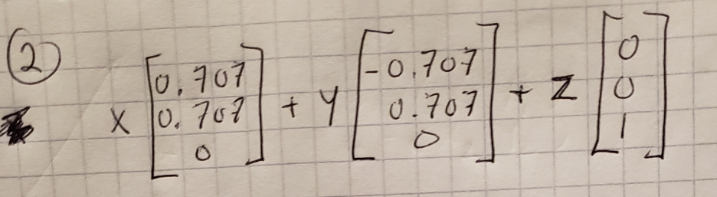

1. If we wanted to multiply a **column** vector with a square matrix such that the vector was on the left and the matrix was on the right, could we do it? If so, how? If not, what would we have to do to in order to be able to multiply them? (15 pts)

You are not able to multiply a column vector with a square matrix when the column vector is on the left and matrix is on the right. In order to be able to multiply them, you must transpose the column vector and the matrix before multiplying them together.

1. (True / False) The term orthogonal has the same meaning for both vectors and matrices. (3pts) FALSE – They are close in meaning, but for a matrix all vectors need to be orthogonal AND they all have to have the same length/magnitude.
2. (True / False) An orthogonal matrix’s rows and columns are both mutually orthogonal to each other **and** unit length. (3pts) TRUE
3. Is the matrix below orthogonal? Show why or why not. (6pts)

$$M=\left[\begin{matrix}\cos{θ} & \sin{θ} \\ -\sin{θ} & \cos{θ}\end{matrix}\right]$$

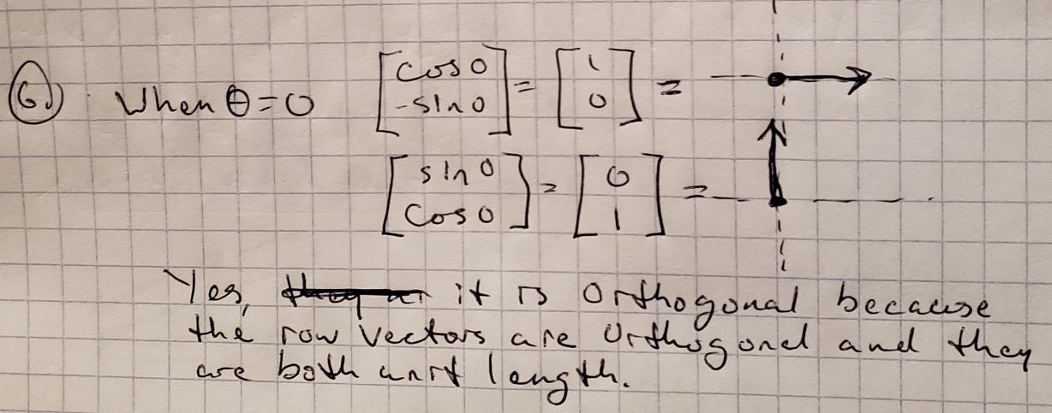

1. (True / False) ${\left(ABC\right)}^{T}=C^{T}B^{T}A^{T}$ (1pt) TRUE
2. (True / False) ${\left(ABC\right)}^{-1}=A^{-1}B^{-1}C^{-1}$ (1pts) TRUE
3. (True / False) Matrix multiplication does not commute for **any** pair of matrices $A and B$. (2pts) FALSE
4. Derive a 2x2 rotation matrix. Your answer should include a labeled graph and an English description of what it is and how you are depicting it. (10pts)

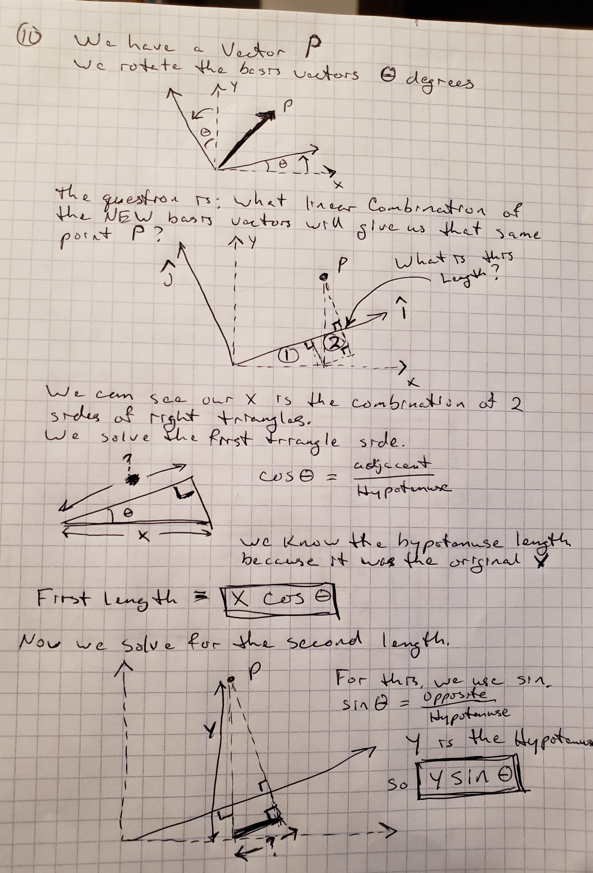

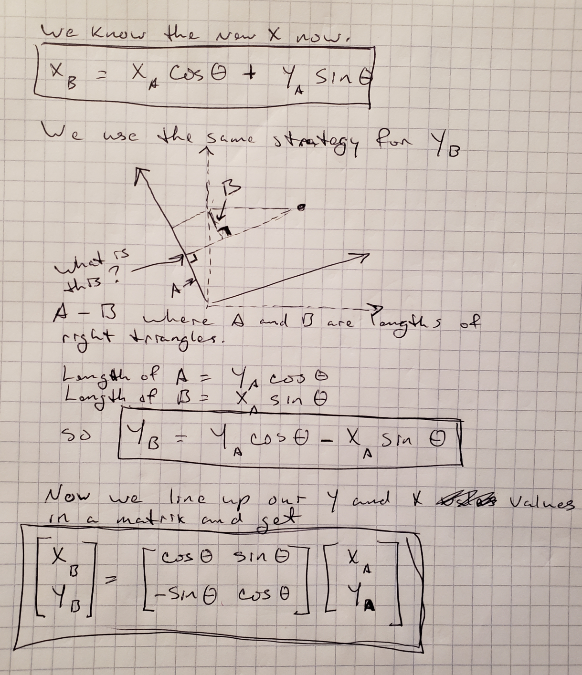

1. When is a matrix transpose also equal to its inverse? (3pts) When the matrix is orthogonal.
2. (True / False) A rotation matrix only rotates about the current origin (the zero vector). **Justify your answer**. (3pts) TRUE – The rotation is based upon theta degrees around the origin. If the rotation took place around any other point, that point would need to become the new origin.
3. (True / False) A scale matrix will displace any vector it is applied to by the same amount. In other words, the distance between the vector’s original location and its new scaled location will be the same amount for every vector. **Justify your answer**. (2pts)

FALSE – If you apply a scale matrix to a zero vector, the distance between the vector’s original location and its new scaled location will be 0. However, if you were to scale any other vector with the same scale matrix applied to the zero vector, the distance between the original location and the new location would not be 0.

1. What is the geometric interpretation of the determinant in both 2 & 3 dimensions? (3pts)

The geometric interpretation in 2D is the change in area that a 1x1 grid occupies. If the area doubles, the determinant is 2. In 3D is the volume change of a 1x1x1 cube in the space.

1. With respect to transformations, name one way that a matrix inverse useful. (2pts)

The matrix inverse is useful with respect to transformations because it can allow us to undo another transformation if it is performed in sequence.

1. Given a vector $V=\left[\begin{matrix}x \\ y \\ z\end{matrix}\right]$ and a matrix $M=\left[\begin{matrix}u_{0} & v_{0} & w_{0} \\ u_{1} & v_{1} & w_{1} \\ u_{2} & v_{2} & w_{2}\end{matrix}\right]$, create an expression that is equal to product $MV$, only the vector is multiplied from the left. (6pts)

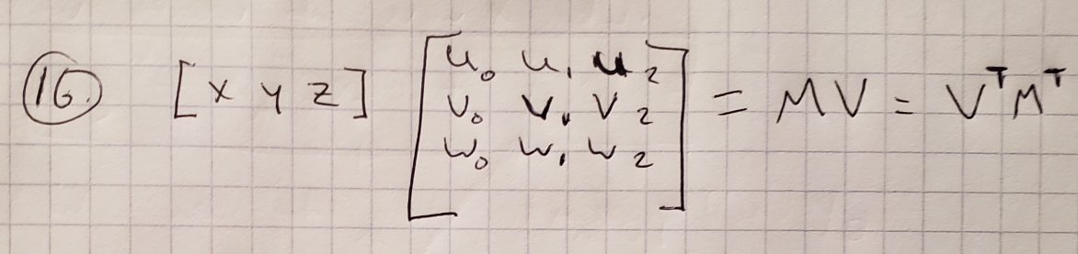

1. What is “gimbal lock” and how does it happen? (3pts)

Gimbal lock is when one degree of freedom is lost in a 3 dimensional plane of rotation. This is caused by representing an orientation as three axial rotations with Euler angles. This will make one of the basis vectors in a plane of rotation rotate in a way such that is aligns with the axis of rotation of another vector, therefore losing one degree of freedom.

1. What are homogeneous coordinates? (2pts)

It is an additional coordinate in the matrix that is not a typical dimension and allows for translation.

1. How do homogenous coordinates facilitate translation in a matrix? (5pts)

Homogeneous coordinates facilitate translation in a matrix by making it possible to add perspective and distance to the standard 2D or 3D object. The “extra” coordinate is kept normalized in the vector. When the transformation matrix is multiplied by that vector, it allows for affine transformations of 2d vectors with a 3d matrix or affine transformations of a 3d vectors with a 4d matrix.